Home > Molecular Techniques > Agarose Gel Electrophoresis for DNA
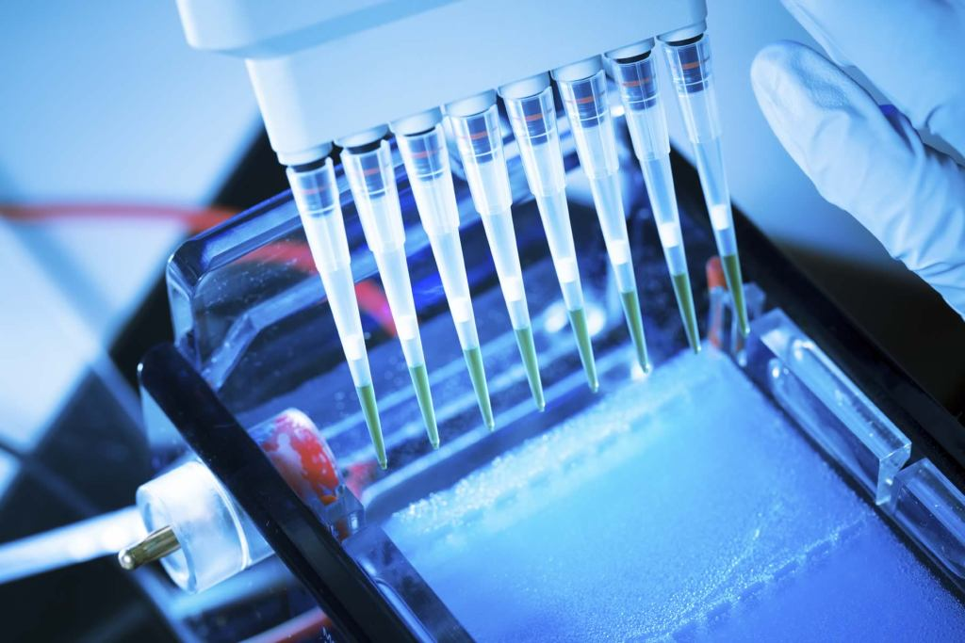

Agarose Gel Electrophoresis for DNA
Molecular Techniques, Nucleic acid methods / January 14, 2019 / By Abdul Saboor

INTRODUCTION
Agarose gel electrophoresis is the most common method of gel electrophoresis in different fields such as genetics, molecular biology, clinical and biochemistry for the separation of biological molecules like nucleic acid and proteins in an electric field. Agarose is a main component of agar and in the form of the gel has numerous small pores which are responsible for the separation of molecules. The pore size of agarose gel can be controlled by varying the concentration of agarose. Agarose gel is easy to handle and contains fewer charged species. Most of the time, researchers use these gels for the separation of DNA having a size range that is normally come across in research labs. At the end of electrophoresis separated DNA fragments can be extracted from the gel for further analysis.

CHARACTERISTICS OF AGAROSE GEL
Agarose is a linear type of polymer that consists of a long chain of D and L-galactose in an alternating manner. The supercoiled structure is formed by aggregating helical fibers of agarose chains. These supercoiled structures have 20-30 nm radius. By gelation of agarose, a mesh of three-dimensional channel is formed that has a diameter range from 50 nm to 200 nm. Normally 800 galactose residues per chain of agarose polymer are present in commercially prepared stock. In low-grade agarose, there are many other impurities that are usually present like salts and other proteins and effects the stability of the gels, gelling or melting temperature of agarose solutions and the sieving of DNA. So, to avoid these problems special grades of agarose are used that are screened for nucleases and inhibitors.
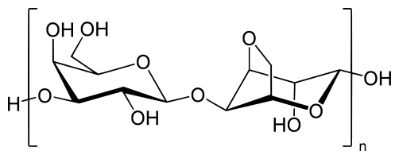
Fig.01: The structure of an agarose polymer

PRINCIPLE FOR AGAROSE GEL ELECTROPHORESIS
Agarose gel electrophoresis is mostly used for the separation of double and single-stranded DNA molecules. The nitrogenous bases of DNA have a negative charge due to a phosphate group at the ends. So negative charged DNA molecules migrate towards anode when an electric field is applied. DNA moves through the small pores of agarose gel, therefore, the rate of migration of larger molecules is low as compared to smaller molecules. So, after a certain time period, separated bands of DNA are formed. These DNA bands can be seen under the UV light due to the presence of fluorescent molecules of ethidium bromide between the DNA nitrogenous bases.
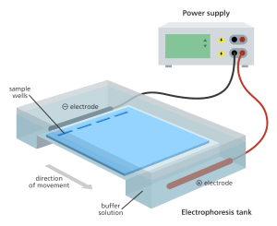Agarose gel electrophoresis setup
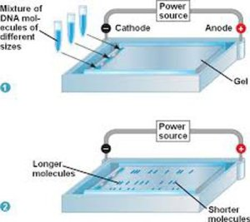Separation of DNA molecules on the agarose gel

RATE OF MIGRATION:
There are some factors which affect the rate of migration of DNA through the agarose gel pores.

1. THE MOLECULAR SIZE OF DNA:
Large sized molecules of DNA move slowly due to high frictional force and smaller molecules of DNA move faster as they can pass through pores of the gel easily as compare to larger molecules. The migration rate of double-stranded DNA molecules from the pores of the gel is inversely proportional to the log10 of the number of base pairs.

2. AGAROSE CONCENTRATION:
Pore size of agarose gel is controlled by varying the concentration of agarose during gel synthesis. Pore size is adjusted with respect to the size of DNA fragments. If DNA fragments in the sample are short then pore size should be small enough to get better results with high resolution. By increasing agarose concentration pore size of the gel decreases and vice versa.

3. THE CONFORMATION OF DNA:
The conformation of DNA also effects the rate of mobility of DNA from the gel. There are three common conformations of DNA; superhelical circular, nicked circular and linear. The rate of mobility of these forms primarily depends upon type and concentration of agarose, the strength of applied electric field and ionic strength of buffer. In some conditions, superhelical circular DNA moves faster than others and a linear molecule of DNA has the lowest mobility but it can be reversed in other conditions.

4. EFFECT OF ETHIDIUM BROMIDE:
Ethidium bromide intercalates between the strands of DNA double helix due to this, negative charge of DNA decreases and length increases. So due to this the rate of migration of DNA during electrophoresis by using agarose gel declines by a factor of approximately 15%.

5. APPLIED VOLTAGE:
Migration rate of DNA on the gel is proportional to the applied voltage for linear DNA fragments at low voltage. If the applied voltage is raised, the mobility of high weight molecules of DNA fragments increases differentially. So due to this, the effective range of separation of DNA fragments in agarose gel decreases by increasing applied voltage. The agarose gels should be run at 5-8 V/cm for obtaining high-resolution results of DNA fragments less than 2 kb in size.

6. EFFECT OF ELECTROPHORESIS BUFFER:
Ionic strength and composition of the electrophoretic buffer commonly affect the electrophoretic mobility of DNA fragments in agarose-based gels. If water is used in electrophoresis instead of the buffer then electrophoretic mobility of DNA fragments will be low. By using high ionic strength buffer conductance is produced very efficiently, due to this significant amount of heat is produced, it denatures the DNA fragment and melts the gel even by applying normal voltage.

7. TYPE OF AGAROSE:
There are two types of agarose that are common in the molecular labs such as low melting agarose and standard agarose. The third type of agarose is growing class agarose that has both gelling/melting temperature agaroses and shows characteristics of each of the two major classes. There are many classes in each major class of agarose for specific applications.

GEL LOADING BUFFER:
Before loading the sample into the slots of the agarose gel, Gel loading buffers must be mixed with the samples for following three purposes.
1. Gel loading buffers increase the density of the sample otherwise samples will not evenly sink into the wells and float at the surface of electrophoresis buffer in which gel is soaked, so it simplifies the loading of sample.
2. Loading buffer gives color to the sample due to this loading of the sample become easy.
3. Loading buffers contain dyes that move towards anode when a voltage is applied. It makes easy to visualize transfer of DNA through the gel. The rate of mobility of dyes depends upon the chemical nature of it. So each dye has different rate mobilities. Xylene cyanol FF moves nearly 2.2 folds slower than bromophenol blue.

ELECTROPHORESIS BUFFERS:
There are different kinds of electrophoresis that can be used for the separation of native DNA by using agarose gel. These buffers are normally used at the concentration of nearly 50mM Like TAE (Tris-acetate EDTA), TBE (Tris-borate) and TPE (Tris-phosphate). Optimum pH for these buffers is 7.5-7.8.
The buffering capacity of TAE buffer is lowest among these buffers. If electrophoresis is performed for long period of time TAE buffer will become exhausted. When this happens the anodic portion of the agarose gel become acidic due to this bluish-purple color of bromophenol blue turns into yellow. This change in color usually happens at pH 4.6 to 3. So, to avoid exhaustion periodic replacement of TAE buffer should be done during electrophoresis or by recirculating the buffer between two reservoirs.
For high molecular weight double-stranded DNA molecules TAE has better resolving power than TPE and TBE, but for low molecular weight DNA, its resolving power is not much better. DNA fragments can move 10 times faster through the gel in TAE buffer than TPE and TBE. The supercoiled DNA molecules have better resolution in TAE than TBE. So usually TAE buffer is mostly used in Southern blotting.

DETECTION OF DNA BY USING ETHIDIUM BROMIDE:
Staining DNA by using ethidium bromide for detection is the most common method. Ethidium bromide is a tricyclic planar fluorescent dye that emits radiations in the presence of UV light. EtBr is present in the gel and intercalates between the stacked DNA bases. It binds randomly to DNA without any sequence preference. EtBr molecules lie perpendicular to the axis of double-stranded DNA between the bases. Vander wall forces make the interaction between EtBr and base pairs of the DNA.
EtBr molecules that are attached to DNA helix yield nearly 20-30 times more fluorescent than unbound molecules of EtBr. Due to this, bands containing DNA as little as 10 ng can be detected. DNA absorbs UV radiations at 254 nm and then transmit it to the dye. Dye also absorb UV light at 302 nm and 366 nm. Fluorescent dye emits radiations of 590 nm in the visible region (red-orange). So, anyone can detect single and double-stranded DNA by using ethidium bromide although single-stranded DNA has little affinity for ethidium bromide.
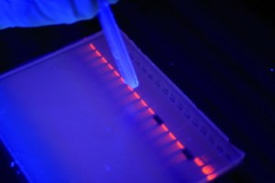Glowing bands due to EtBr on Agarose gel

