Genomic DNA Extraction – Principle, Steps and Functions of Reagents
Molecular Techniques, Nucleic acid methods / January 13, 2019 / By ShahiD Ali
Table of Contents
1. Genomic DNA Extraction – Principle, Steps and Functions of Reagents 2
2. Principle 2
3. Steps of DNA Extraction 3
I. Sample Collection and Preparation 3
II. Cell Lysis 4
a) Lysis Buffer 4
b) Detergents 4
c) Reducing agent 5
d) Chelating agents 5
e) Tris Buffer 5
f) Salt – NaCl / KCl 5
III. DNA Precipitation 5
a) Ethanol precipitation 5
b) Phenol–chloroform extraction 5
♣ Phenol 6
♣ Chloroform 6
♣ Isoamyl Alcohol 6
c) Minicolumn Purification 6
IV. Resuspension 7
V. Detection 7
a) Spectrophotometer 7
b) Agarose Gel Electrophoresis 7
4. DNA Purity Test 8

Genomic DNA Extraction – Principle, Steps and Functions of Reagents
DNA extraction from a sample is a process of purifying the DNA. The sample can be tissue, plant or animal cells, blood, viral DNA or any other DNA containing the sample. The idea of extracting the DNA is quite basic: Disruption of the cell membrane (and cell wall in case of plant cells) to make the DNA exposed and then separate it from the rest of the cell debris. In this article, we will mainly discuss the extraction of genomic/chromosomal DNA found inside the nucleus of eukaryotic cells.

Principle of DNA Extraction
Firstly, the cell membrane is disrupted physically or chemically to get a fluid containing all the cell components including DNA. The process is called cell lysis and the resulted fluid is known as lysate. During cell lysis, different chemicals and reagents are used to break down different cell components e.g. Lipids are broken down by detergents and surfactants, proteins are broken down by protease and RNA is broken down by using RNase. Secondly, the lysate is treated with a concentrated salt solution to make the broken components clumped together and leave the DNA freely floating in the solution. Thirdly, this solution (containing lysate, detergents, surfactants, broken proteins, lipids and RNA) is centrifuged to separate the clumped debris from DNA. Lastly, DNA precipitation is done by adding ice-cold alcohol plus salt to increase the ionic strength which increases the precipitation process. A pellet of DNA is obtained upon centrifugation of this solution. The supernatant is discarded except for the DNA pellet which remains stuck to the walls of the Eppendorf. Pellet is, then, suspended either in slightly alkaline solution mostly TE buffer or ultra-pure water (organic particles and dissolved gases removed) for subsequent DNA experimentation usually PCR (Fig 01).
Read : Lehninger Principles of Biochemistry 7th Edition 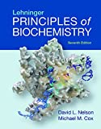
25 Countries that Don’t Like Americans
100% Free Nude Celebrity Leaked Pics
Best Exercises to Relieve Neck Pain When Working at Computer
12 Funniest Sports Pictures Ever Captured (Perfect Timing)
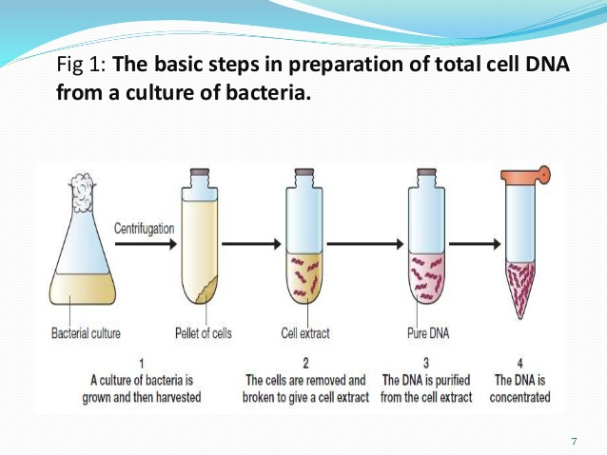DNA extraction steps

Steps of DNA Extraction

Sample Collection and Preparation
DNA can be extracted from a number of sources such as human hair, urine, saliva, tissue, plant or animal cells etc. Each kind of sample is collected accordingly. For example, Saliva is collected by using cotton swab, urine is collected and frozen later on, plant leaves and human hair are easy to be collected in non-invasive way. After the successful collection each kind of sample is washed with water, organic solution or various buffers to remove any kind of contamination from the sample. If the sample is bacterial cell, preparation includes keeping the bacterial culture overnight, taking 1ml from overnight kept bacterial sample and centrifugation of this 1ml bacterial culture to get the pellet of bacterial cells. Later on lysis of the cell pellet is done by adding lysis buffer into it. Table 01 shows various types of sample and the potential amount of DNA that can be extracted from it.
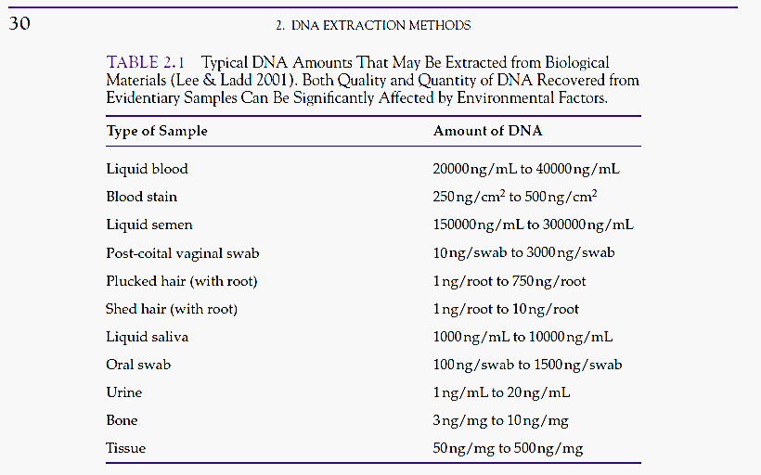Table 1: Types of Samples and Amout of DNA in them Amount of DNA in them

Cell Lysis
Plant cells are disrupted physically using pestle and mortar along with liquid nitrogen because they have rigid cell wall around them. Powder plant tissues is then transferred to Eppendorf and suspended in suitable buffer such as CTAB lysis buffer. Animal cells are disrupted chemically mostly using SDS lysis buffer (Fig 02).
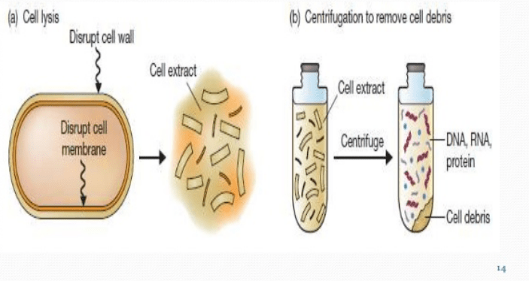
Figure 2 (a) Cell Lysis to get cell extract or lysate. (b) centrifugation of cell extract to separate the DNA from Cell debris

Lysis Buffer
There are different buffers available for different kind of tissues. CTAB lysis buffer is used mostly for plant cells. SDS lysis buffer is used when animal cells are being disrupted. But major components of the lysis or extraction buffer are same and performs same function in DNA Extraction.

Detergents
CTAB buffer is a cationic buffer mostly used for plant cell disruption while SDS is anionic detergent used during animal cell lysis. Both SDS and CTAB interferes with membrane proteins and lipids bilayers leading to the disruption of the membranes of internal organelles, plasma membrane as well as nuclear membrane.

Reducing agent
β-mercaptoethanol acts as a reducing agents and cleaves the disulphide bridges present between different polypeptides of a proteins leading to the denaturation of the proteins.

Chelating agents
DNase present in the cells can degrade the DNA. EDTA acts as chelating agents and binds to Mg²⁺ ions which acts as co-factors for DNase. The unavailability of Mg²⁺ ions leads to the deactivation of DNase activity and hence saves the DNA from degradation. EDTA also weakens the membrane stability.

Tris Buffer
DNA is pH sensitive and can be degraded on pH change. Tris acts as pH stabilizer during cell lysis process. It maintains the pH at 8.

Salt – NaCl / KCl
The cations Na⁺ or K⁺ binds to negative phosphate groups of DNA and makes it more stable in aqueous solution. In the absence of Na⁺ or K⁺, DNA molecules repel each other and do not allow grouping of DNA molecules.

DNA Precipitation
Precipitation separates the DNA form broken down cell components during DNA extraction process. There are three major types of DNA separation from cell debris.

Ethanol precipitation
Ice cold ethanol is added to the solution containing DNA and cell debris. Proteins gets dissolved in ethanol. Upon centrifugation, DNA is obtained in the form of pellet on the bottom of Eppendorf. Supernatant containing cell debris is discarded and DNA pellet is washed with ethanol to remove any salts or impurities. Centrifugation is done again, supernatant is discarded, pellet is air dried and then the pellet is suspended in pure water or suitable buffer for storage.
Isopropanol can also be used instead of ethanol. Isopropanol is more effective in precipitation but it is less volatile than ethanol so more time is required for air drying.

Phenol–chloroform extraction
A mixture of phenol: chloroform: isoamyl alcohol (25: 24: 1) is added to the solution. Upon centrifugation, two distinct phases are obtained with a white interface between them (Fig 03).
- Aqueous phase contains the DNA
- Organic Phase (Phenol: chloroform) contains the broken down proteins, lipids, and other cell debris.
- Interface contains white fragments of lysed proteins
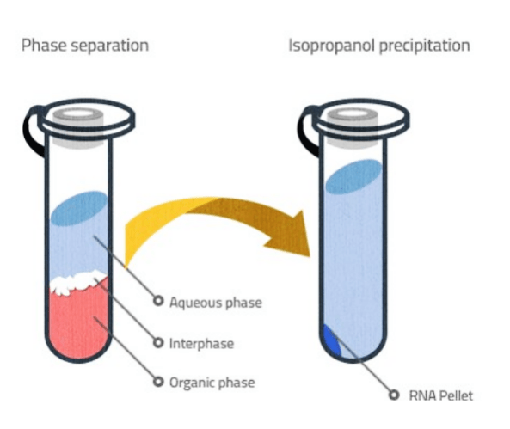Fig. 3: Phase Separation Method eparation Method
DNA is separated by pipetting out the upper aqueous phase very carefully. This step can be repeated more than once to remove more contamination. DNA is then suspended in phenol and centrifugation is performed to get DNA pellet.

Phenol
In the cell, proteins normally folds in such a way that the polar part of the proteins remain on peripheral areas and non-polar part moves to the core of the proteins. As phenol is less polar than water, so proteins gets denatured slightly and dissolved in phenol. DNA being more polar dissolves in upper aqueous phase.

Chloroform
It increases the viscosity of the organic phase and avoids phase shifting leading to more accurate phase separation.

Isoamyl Alcohol
It acts as anti-foaming agent.

Minicolumn Purification
Minicolumn purification is a solid phase DNA extraction method in which DNA is bound to silica column by spinning. Later on DNA is eluted by using a suitable elution buffer (Fig 04).
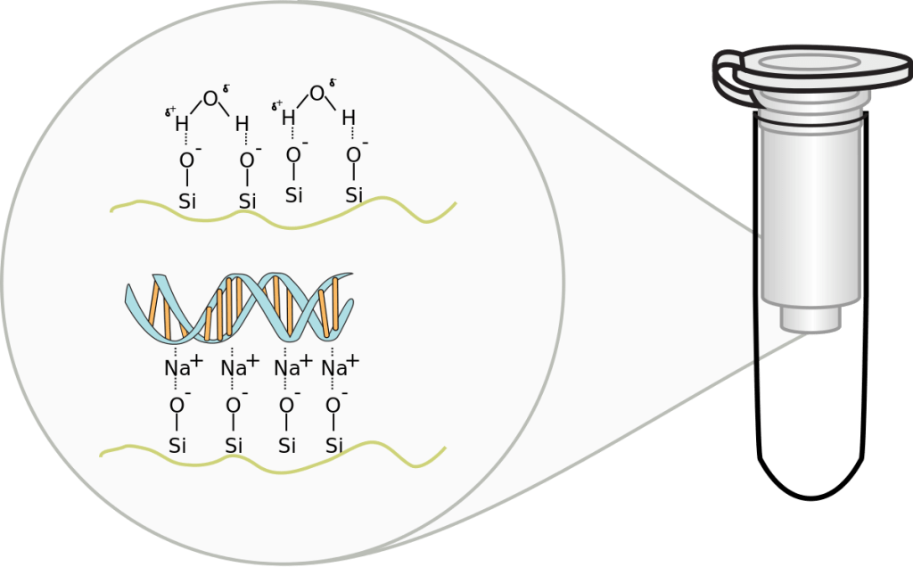Fig. 04 : Mini Column Separation of DNA

