SSR college of Arts, Commerce and Science
Sayli, Silvassa.
ICT- ENABLED FACILITIES
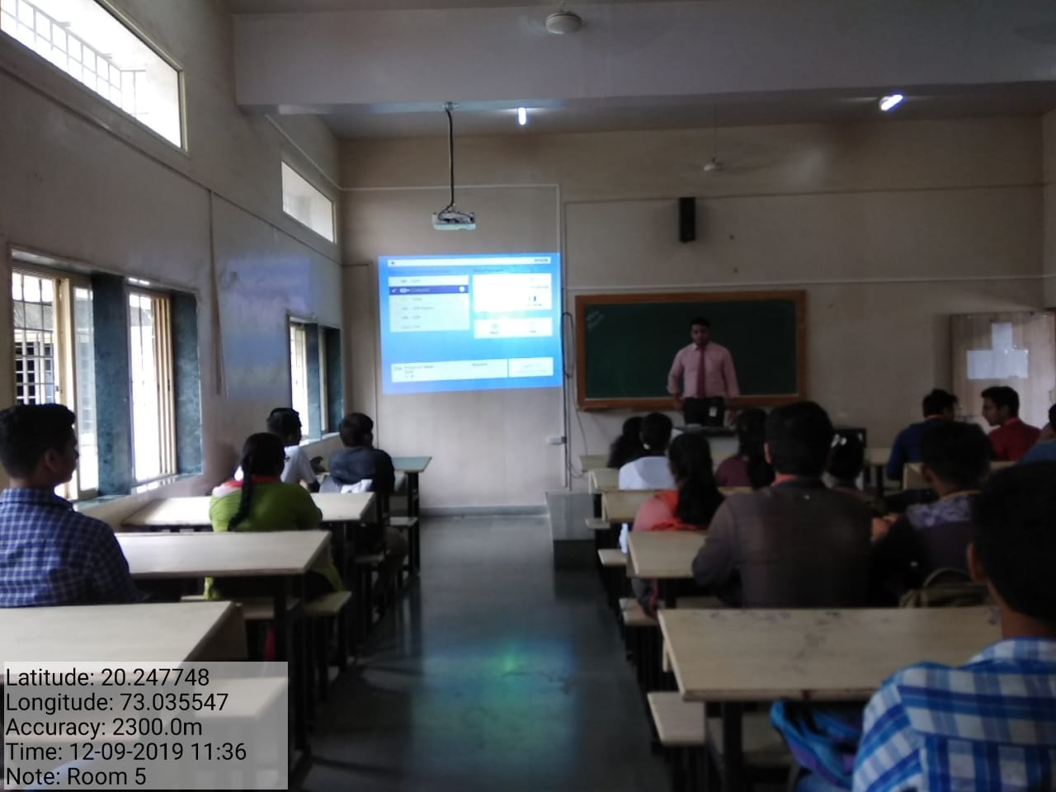

Room No-5

SSR college of Arts, Commerce and Science
Sayli, Silvassa.
ICT- ENABLED FACILITIES
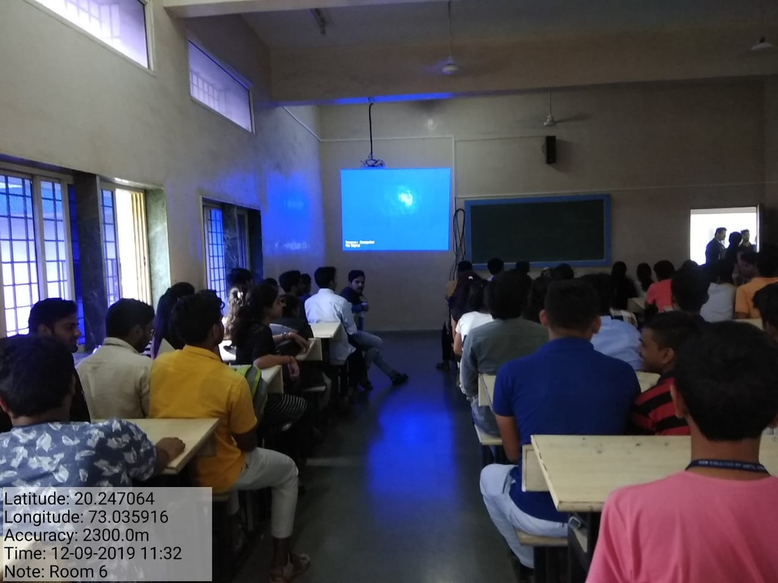

Room No-6

SSR college of Arts, Commerce and Science
Sayli, Silvassa.
ICT- ENABLED FACILITIES
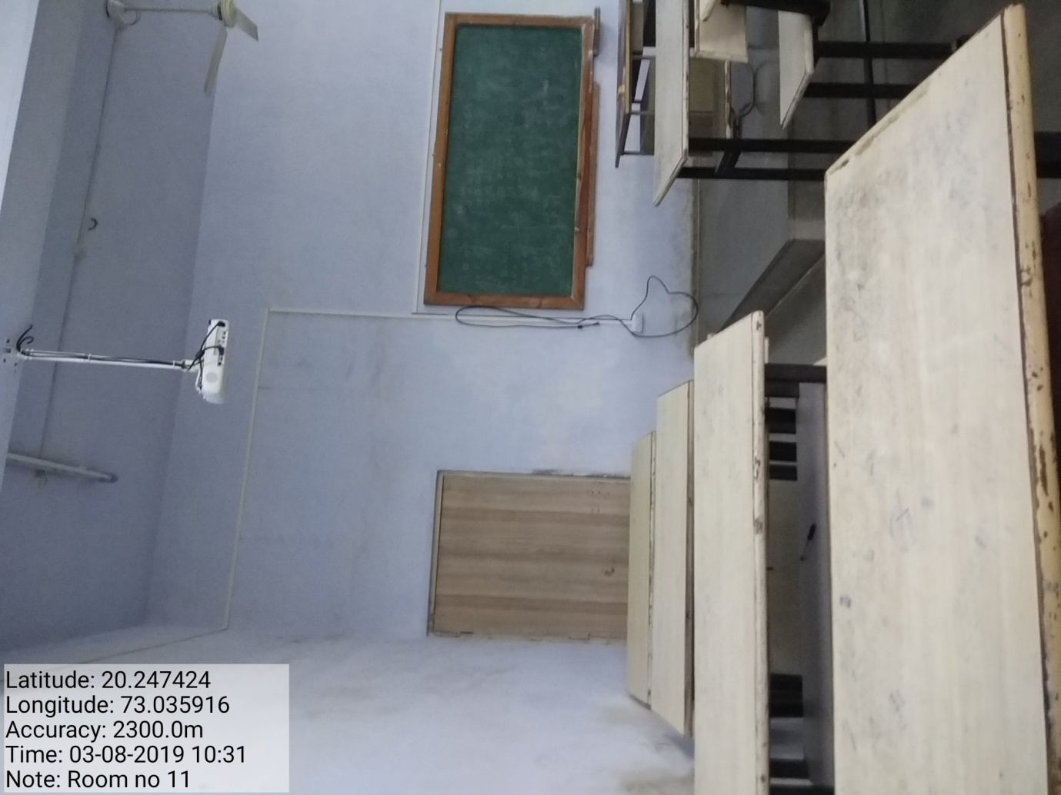

ROOM NO- 11

SSR college of Arts, Commerce and Science
Sayli, Silvassa.
ICT- ENABLED FACILITIES
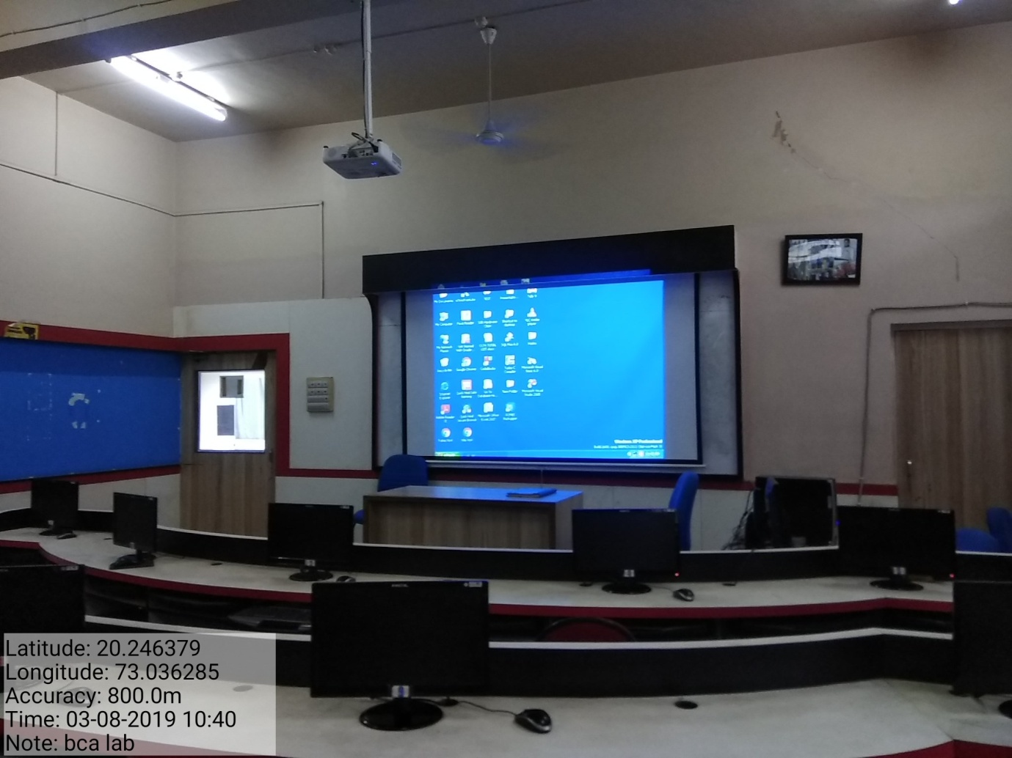

BCA LAB

